eTools (Speaker: Ms. Sarah Schroeder, Assistant Professor, Instructional Design and Technology Program, UC; July 2, 2015, 9:00 am–11:30 am)
Ms. Sarah Schroeder is a field service assistant professor in the instructional design and technology program at the UC. After teaching high school theater, English, and speech, Sarah combined her passion for media studies, communication, teaching and design to support teachers developing digital learning experiences. She now works with faculty in the School of Education to implement e-learning solutions and trains faculty university-wide through UC’s Center for the Enhancement of Teaching & Learning (CET&L). Sarah is a graduate of the Educause Educational Technology Leadership Institute, a member of the UC Blackboard training team and a Quality Matters master reviewer and certified trainer. She is passionate about issues of access and designing eLearning for diverse learners. The project she is currently most excited about is working with under-served schools such as Ethel Taylor Academy Elementary School and Hughes High School. There she is exploring blended learning solutions to improve student engagement and performance.
- Ms. Schroeder began her presentation by giving a personal history of her own technological background. She began her career as a teacher and this has profoundly shaped her attitude toward technology use and pedagogy. The agenda for the session was: The Big WHY.
- Checking on Where We Are.
- The SAMR Model.
- Important Considerations.
- Practice, Practice, Practice.
Ms. Schroeder emphasized the importance of focusing on student learning as the primary goal, and the technology as one way to improve student engagement and teacher efficiency. Ms. Schroeder led the class through an activity identifying tasks that students were engaged in and technology that could be used to do the task. The point of the exercise was that teachers should design good learning tasks for students, and then examine how technology might make the task more efficient or effective. Emphasis was placed on the fact that the technology used should serve the students and teachers, not the other way around. Ms. Schroeder also suggested teaching students a defined repeatable protocol around the usage of any technology that will be regularly used in class.
Ms. Schroeder also addressed the “scare factor” that prevents many teachers from integrating useful technology into their classroom. Ms. Schroeder pointed out that there are so many educational applications and websites that it can be overwhelming for a teacher. It was suggested that teachers think of just one way in which they can integrate technology that would increase student engagement and learning, and begin with something small.
Ms. Schroeder introduced the SAMR model for technology integration in the classroom, the elements of which are presented in Table 1, presented on next page.
Ms. Schroeder then had the participants break into groups and generate criteria for evaluating educational technology tools, and share those criteria on a shared Google document, which she then reviewed with the whole group.
Finally, Ms. Schroeder provided a list of educational technology tools, and participants were asked to “test-drive” some of the tools in the list and think about how they could be used to increase student learning in their classrooms.
Table 1: SAMR Model for Technology Integration in the Classroom
Substitution | Technology acts as a direct tool substitute with no functional change (e.g., online flash cards instead of physical flash cards)
Augmentation | Technology acts as a direct tool substitute with functional improvement (e.g., tracking changes and comments on a student composition on Google docs instead of on multiple hard copies)
Modification | Technology allows for significant task redesign (e.g., having conversational exercises in a language class with students video conferencing with native speakers in another country)
Redefinition | Technology allows for the creation of new tasks, previously inconceivable (e.g., Instead of solving a problem, students write a computer program to solve a class of problems.)
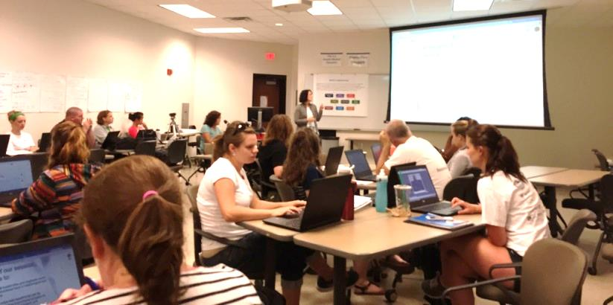
Figure 2: Ms. Schroeder Beginning Her Presentation
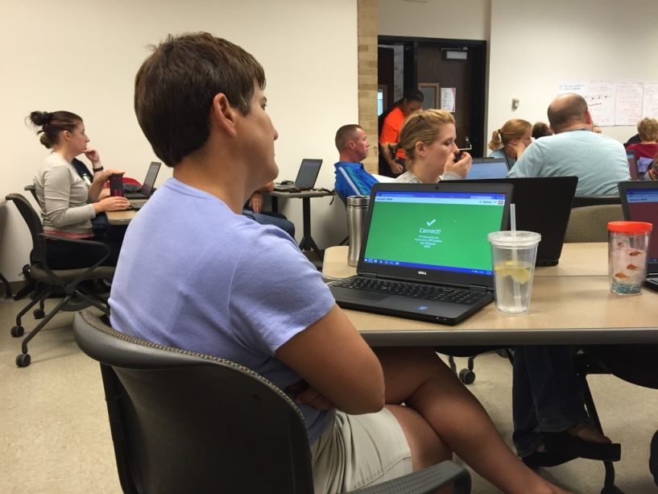
Figure 3: Participants Engaging in an Interactive Online Survey
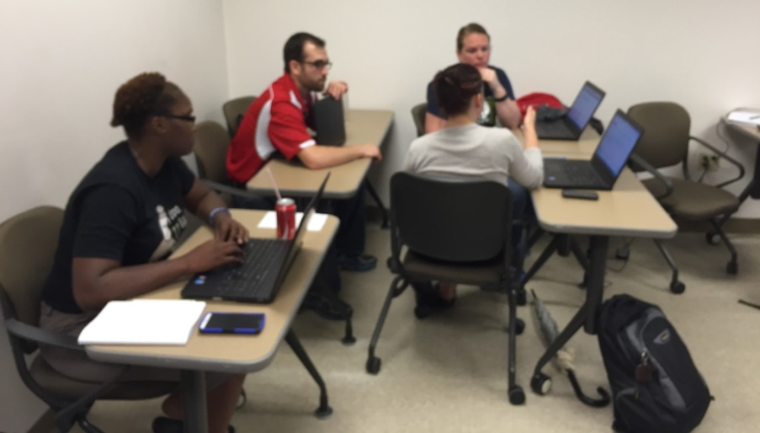
Figure 4: Participants Discussing Criteria for Evaluating Educational Technology Resources
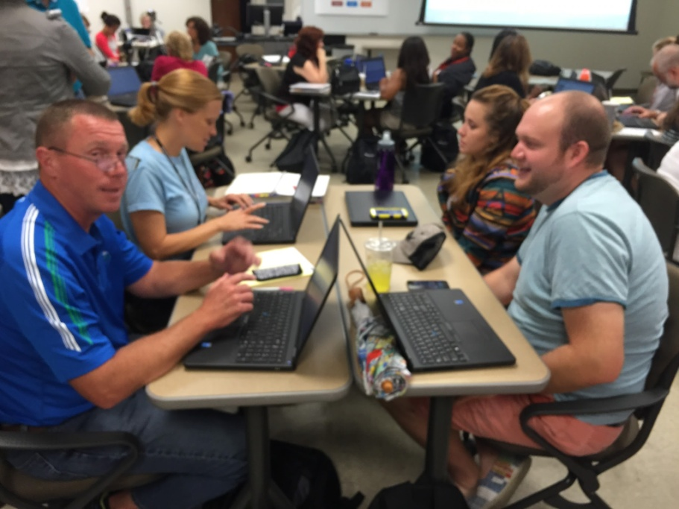
Figure 5: Teachers Exploring a Variety of Educational Technology Resources

